Computer Language Coding Concepts

Command Call in a Diagram
The principle of command calls is explained in the article Command Call. This article demonstrates its expression in a diagram.

A command call has a diamond shape, which stands for execution:



A call redirects its class to its definition. So a call is an active command symbol with a definition line:

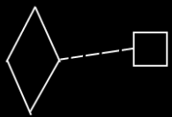

Because the definition is the prototype of the call, and not the same object as the call, a dashed class line needs to be used to point out the definition of a call.

A call does not have to be placed inside another command. It can also be placed inside an object, in case of which somebody has to run the executable object manually.

See also: Command Call, Commands

Author & Copyright: Jan-Joost van Zon Date: May 24, 2008 – August 18, 2008 Location: Oosterhout, The Netherlands Status: Finished

